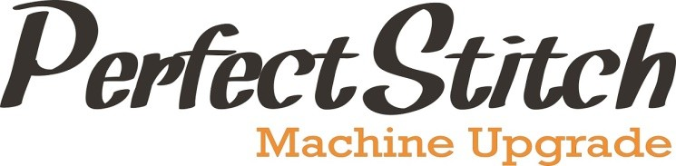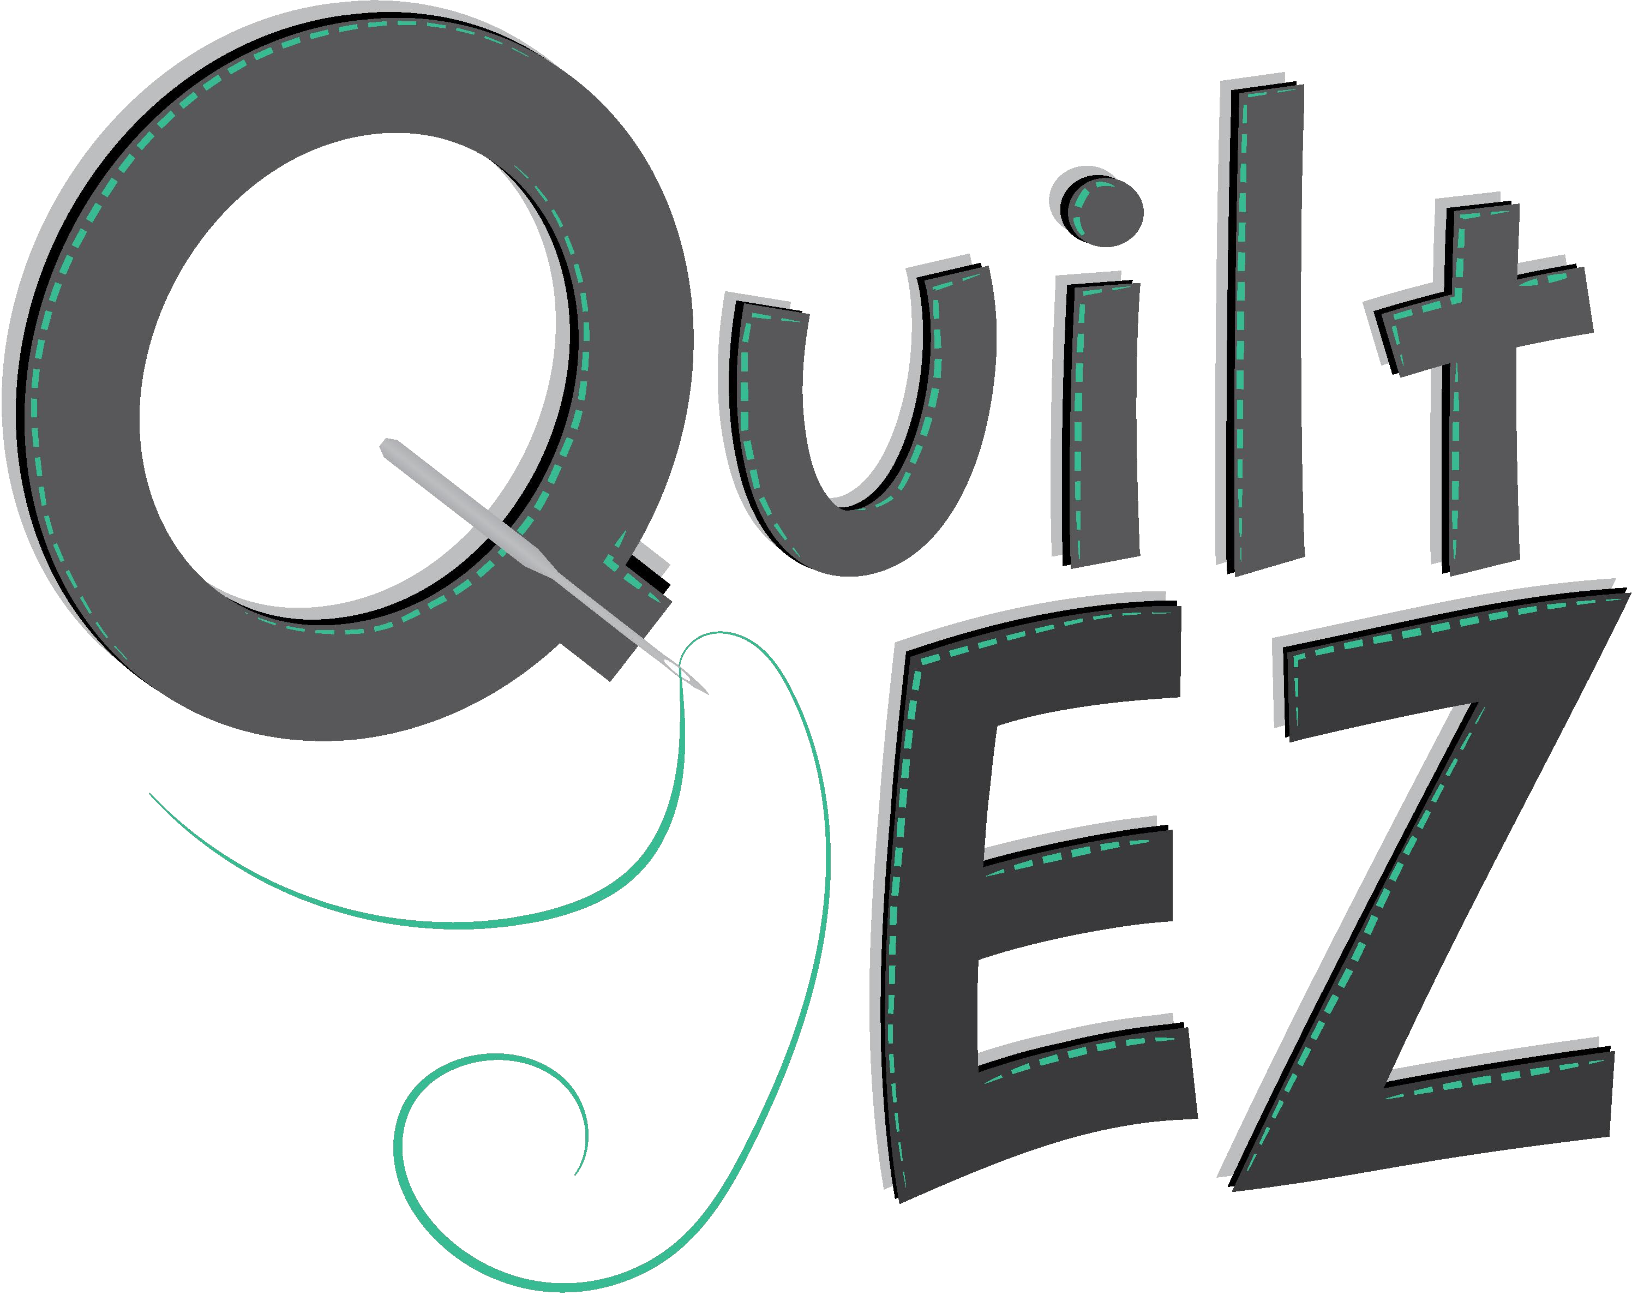

**Warranty**

# Original Warranty Void

The installation of Perfect Stitch on a quilting machine voids any and all original Manufacturer Warranty. Quilt-EZ provides warranty coverage of Perfect Stitch Components.

# Warranty Coverage

Perfect Stitch comes with a limited 24 month Warranty. This warranty is not transferrable, and only applies to the original End User.

Quilt-EZ warrants that the Hardware shall be free from material defects in design, materials, workmanship, and will function, under normal use and circumstances, for a period of 24 months after registering Perfect Stitch with the Dealer from whom Perfect Stitch was purchase or registering online at [www.quiltez.com.](http://www.quilt-ez.com/)

Hardware is defined as including:

* Rear power box
  + Controller board
  + Power supply
  + Plastic case for PC boards
* Machine encoder
* ½ HP motor
* Ball bearing carriage encoders and wires
* All wires for connection between boards and handle bars
* Labor costs for the repair of a manufacture defect or fault of production (only applies during the first 12 months of warranty)

Hardware does not include any software programs, whether pre-loaded with the hardware, installed subsequently or otherwise. If Perfect Stitch is not registered **within two months** of the purchase date, the warranty will be void.

End-User’s sole and exclusive remedy and Quilt-EZ or Dealer sole and exclusive liability for defective Hardware shall be, solely upon confirmation of a defect or failure of Hardware to perform as warranted, either repair or replace the defective part without charge, subject to

the conditions and limitations stated herein. Such repair services will include all labors (during first 12 months) as well as any necessary adjustments and/or replacement parts.

# Warranty Claims

By submitting a warranty claim, Customer accepts and agrees to be bound by all the terms and conditions contained herein. The process for a warranty claim is as follows:

1. Inform dealer as soon as the warranty claim arises;
2. Send to Dealer your original proof of purchase, Perfect Stitch serial number and proof and description of the fault;
3. Subject to the applicable consumer laws in customer’s jurisdiction, customer pays for all packing, freight, transportation, and insurance costs for transit of Perfect Stitch.

If the warranty claim is accepted Dealer will, subject to the applicable consumer laws in customer’s jurisdiction, at its cost:

1. Repair or replace and faulty parts or rectify any faulty workmanship; and
2. Return Perfect Stitch to you

Any Perfect Stitch shipped or delivered to Dealer or Quilt-EZ must have prior notification and approval or the unit will be refused and shipped back to the customer at their expense.

# Warranty on Repaired Parts

All replacement Hardware furnished to End-User under this warranty shall be new or reconditioned to be functionally equivalent to new. Replacement hardware is warranted to be free of defects in material or workmanship for the remainder of the warranty period of the original hardware. All defective hardware, which has been replaced, shall become the property of Quilt-Ez.

# Warranty Restrictions and Disclaimers

Warranty shall be void due to any of the following: (1) if the product has been opened, modified, altered or repaired, except by Quilt-EZ or authorized Dealer, (2) if the product has not been installed or maintained or used in accordance with instructions provided by Quilt- EZ, (3) misuse, abuse, accident, thermal or electrical irregularity, theft, vandalism, fire, water or other peril, (4) damage caused by containment and/or operation outside the



environmental specifications for Perfect Stitch, (5) connection of Perfect Stitch or other systems, equipment or devices or use with other software (other than those specifically approved by Quilt-EZ), (6) removal or alteration of identification labels on the Product or its parts (7) failure to comply with all warranty return terms and conditions as set forth herein.

(8) An Uninterruptible Power Supply (UPS) with Automatic Voltage Regulation (AVR) (online double conversion or line interaction) is not used. Quilt-EZ or Dealer shall not be responsible for any software, information, or memory data ofEnd-User contained in, stored on or integrated with and Perfect Stitch returned for replacement.

# Not Covered in Warranty

The warranty does not cover: diagnostic fee, shipping, and circumstances beyond Quilt-EZ or Dealer control; normal wear and tear, natural disaster, misuse, pest infestation, damages due to accident; damages due to broken or cracked parts, damages due to electrical surges such as lightning or sparks; exposure to liquid or infiltration of foreign particles, servicing or modification of Perfect Stitch other than by Quilt-EZ or Dealer; service or parts to correct problems resulting from the use of attachments, accessories, or alteration not authorized by Quilt-EZ or Dealer; service required as the result of unauthorized modification, upgrading service; failure to follow Quilt-EZ operating and maintenance instructions; use of the product in voltages other than designated voltage.

Repair or replacements of defective parts without charge are Quit-EZ or dealer’s only obligation under this warranty. Whole unit replacement or refund is not an option to this warranty agreement. Quilt-EZ will not be responsible for any consequential or incidental damages resulting from the purchase, use, or improper functioning of the unit regardless of the cause. Such damages for which Quilt-EZ will not be responsible for include, but are not limited to, loss of revenue or profit, downtime cost loss of use of the unit, loos of or damage to the software programs or stored data cost of any substitute unit, facilities or services or claims for such damages.

Quilt-EZ does not warrant that Perfect Stitch is locally certified for electrical compliance in any country.

Quilt-EZ and Dealer reserves the right to repair or replace customers’ units at its discretion; make improvements and or changes to its equipment any time as a unit is submitted for warranty repair; to refuse or reject any and all warranty claims for any reason whatsoever if, based on Quilt-EZ or Dealer’s estimation, damage to subject equipment was not caused by component or factory workmanship defects.

 



**Quilting Made Easy**

If at any time after the purchase of the Perfect Stitch and before the expiration of the warranty, the dealer is no longer in business, contact Quilt-EZ directly to start your warranty claim.

The disposal or use of the machine’s original manufactured parts that Perfect Stitch will replace are subject to the discretion of Quilt-EZ or the user.

# Limitation of Liability

In no event will Quilt-EZ or Dealer be liable for any indirect, incidental or consequential damages of any kind regardless of the form of action, whether in contract, tort including negligence, strict liability or otherwise, even Quilt-EZ or Dealer has been advised of the possibility of such damage, and whether or not any remedy provided should fail of its essential purpose. The total cumulative to End-User, from all causes of action and al l theories of liability will be limited to and will not exceed the purchase price of Perfect Stitch. Some jurisdictions do not allow the exclusion or limitation of incidental or consequential damages, so the above limitation or exclusion may not apply to End-User.

I agree that I have read and understand all terms and claims expressed in the above Perfect Stitch Warranty document.

Customer Signature:

Date:

[www.quiltez.com](http://www.quiltez.com/) 144 South 600 West, Logan, UT 84321

Phone: 435-245-017 Email: [sales@quiltez.com](mailto:sales@quiltez.com) Rev. 2022